
Test Four
Teacher:

Mr Staffe

Mrs. Carter

_____Mr Roohi

_____Ms Cheng

Semester One 2016
Year 12 Mathematics Methods
Calculator Free
Name:

- Complete all questions
- Show all necessary working
- Total Marks = 24
- 24 minutes

1. [4 marks]

Evaluate each of the following showing full working:
- 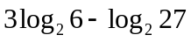 [2]

- 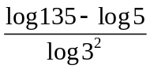 [2]

2. [5 marks]

Solve each of the following equations, showing all working.
- 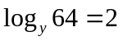 [2]

(b) 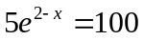 (Leave answer in terms of Logs) [3]

3. [7 marks]

Differentiate each of the following with respect to x, using the appropriate rule and showing full working:

(a) 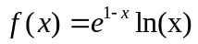 [2]

(b) 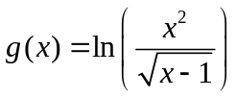 [2]

(c) 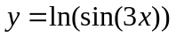 [3]

4. [8 marks]

Determine each of the following anti-derivatives, simplifying your answer where possible:

(a) 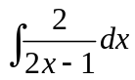 [1]

(b) 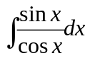 [2]

(c) 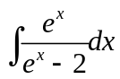 [2]

(d) Calculate the following definite integral, simplifying your answer using logarithmic laws.

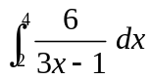 [3]

Teacher:

Mr Staffe

Mrs. Carter

_____Mr Roohi

_____Ms Cheng

Test Four

Semester One 2016
Year 12 Mathematics Methods
Calculator Assumed
Name:

- Complete all questions
- Show all necessary working
- Total Marks = 26
- 26 minutes

1. [ 6 marks ]

The mass M, in grams, of a radioactive substance after t years is given by: 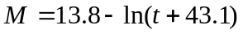
(a) State the initial mass of the substance. [1]

(b) Determine an expression for the instantaneous rate of change of the mass with respect to time. [1]

(c) Calculate the decrease in mass in the 100th year. [2]

(d) Calculate the average decrease in the mass over 100 years. [2]

2. [8 marks]

According to the Apple support site, the time taken to download a 2 hour movie using an ADSL2+ Broadband connection is uniformly between 18 and 24 minutes. Let T be the time taken to download one 2 hour movie from the Apple store.
(a) Sketch the probability distribution function for T. [2]

(b) Calculate the mean time taken to download a movie. [2]

(c) 75% of the time it takes less than k minutes to download a movie. Calculate the value of k. [2]

(d) Calculate 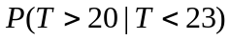 [2]

3. [12 marks]

During December, a local shopping centre has a gift wrapping stall which is open 12 hours a day. On average, the gift wrapping stall serves 120 customers per day.
(a) What is the average length of time between serving each customer at this gift wrapping stall? Give your answer in minutes. [2]

This scenario can be best modelled by an exponential probability density function which is given by 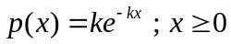 where 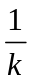 is the mean time between serving customers.
(b) Hence state the probability density function for X, where X represents the time between serving each customer. [2]

(c) Show, using calculus methods, that your answer to part (b) does in fact represent a continuous probability density function. [3]

(d) State the expected value of the distribution. [1]

Calculate the probability that the next customer will be served:
(e) 5 minutes or less after the previous one. [1]

(f) between 5 and 7 minutes after the previous one. [1]

(g) less than 8 minutes after the previous one given that it took longer than 5 minutes. [2]

Test Three
Teacher:

Mr Staffe

Mrs. Carter

_____Mr Bertram

_____Mr Roohi

_____Ms Cheng

Semester One 2016
Year 12 Mathematics Methods
Calculator Free
Name: Mark King-Gyde

- Total Marks = 24
- 24 minutes

1. Evaluate each of the following showing full working:

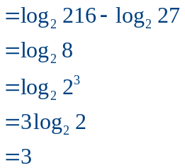
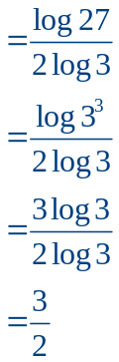

2. Solve each of the following equations, showing all working.
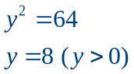

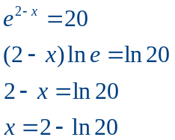
3. [7 marks]

Simplify or Evaluate the following integrals as appropriate
(a)

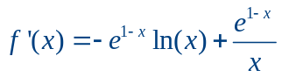

(b)

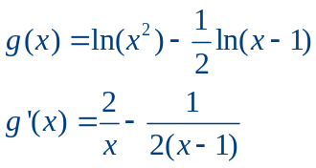

(c)

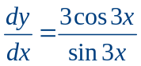

4. [8 marks]

Determine each of the following anti-derivatives, simplifying your answer where possible:

(a)

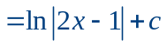

(b)

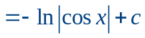

(c)

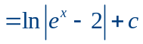
(d) Calculate each of the following definite integrals, simplifying your answers using logarithmic laws.
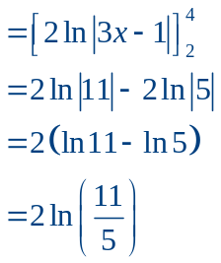

Teacher:

Mr Staffe

Mrs. Carter

_____Mr Bertram

_____Mr Roohi

_____Ms Cheng

Test Three

Semester One 2016
Year 12 Mathematics Methods
Calculator Assumed
Name: Mark King-Gyde

- Complete all questions
- Show all necessary working
- Total Marks = 26
- 26 minutes

1. [ 6 marks ]

The mass M, in grams, of a radioactive substance after t years is given by:
(a) State the initial mass of the substance.
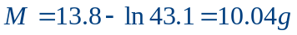
(b) Determine an expression for the instantaneous rate of change of the mass with respect to time.
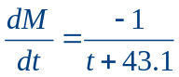
(c) Calculate the decrease in mass in the 100th year.
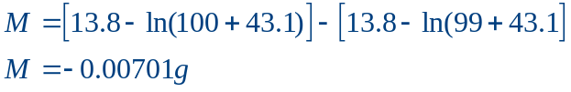
A decrease of 0.00701 g
(d) Calculate the average decrease in the mass over 100 years.
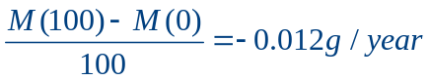

2. [8 marks]

According to the Apple support site, the time taken to download a 2 hour movie using an ADSL2+ Broadband connection is uniformly between 18 and 24 minutes. Let T be the time taken to download one 2 hour movie from the Apple store.
(a) Sketch the probability distribution function for T.
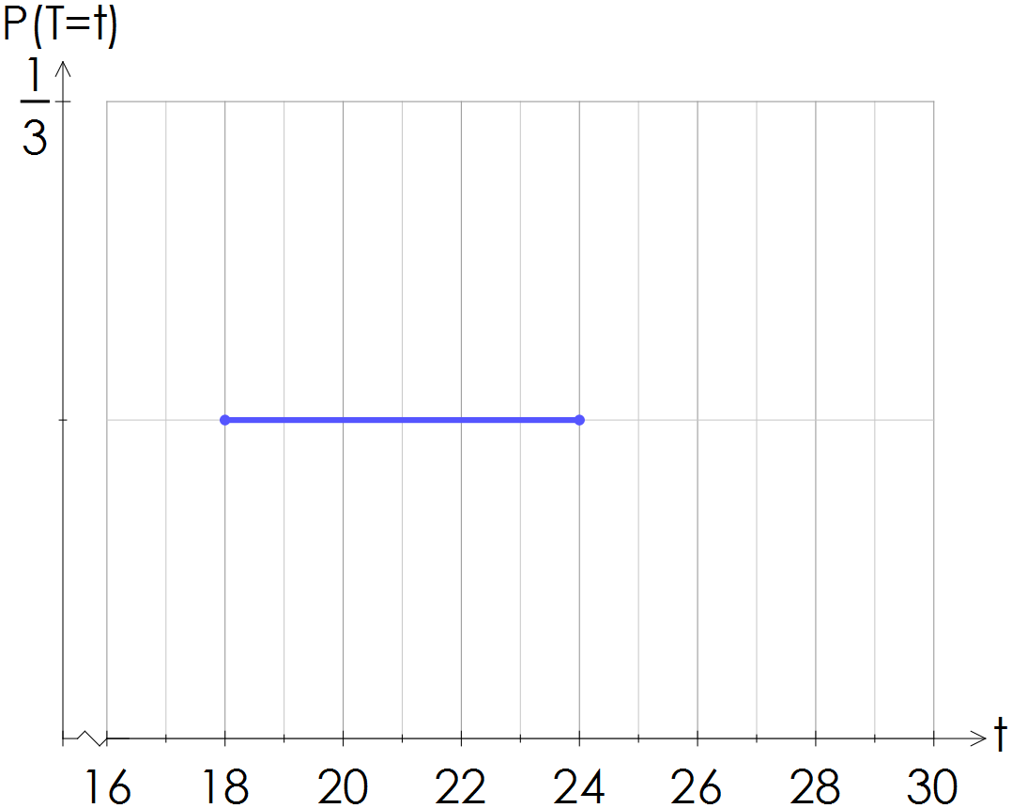

(b) Calculate the mean time taken to download a movie.
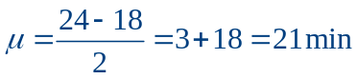

(c) 75% of the time it takes less than k minutes to download a movie. Calculate the value of k.
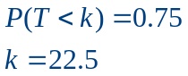
(d) Calculate
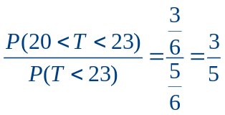

3. [12 marks]
During December, a local shopping centre has a gift wrapping stall which is open 12 hours a day. On average, the gift wrapping stall serves 120 customers per day.
(a) What is the average length of time between serving each customer at this gift wrapping stall? Give your answer in minutes.
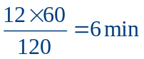
This scenario can be best modelled by an exponential probability density function which is given by where is the mean time between serving customers.
(b) Hence state the probability density function for X, where X represents the time between serving each customer.
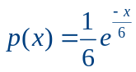
(c) Show, using calculus methods, that your answer to part (b) does in fact represent a continuous probability density function.
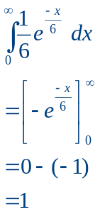
(d) State the expected value of the distribution.
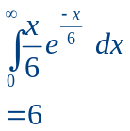
Calculate the probability that the next customer will be served:
(e) 5 minutes or less after the previous one.
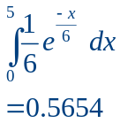
(f) between 5 and 7 minutes after the previous one.
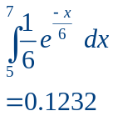
(g) less than 8 minutes after the previous one given that it took longer than 5 minutes.
